**Airline Reservation System**

**Done By:**

Alaa Hussien 202001728

Fatema Gamal 202002674

Liqaa Tarek 202001240

Reem Amgad 202000438

Samaa Maged 202000597

Mohamed Mostafa 202000484

**Project Idea:** Airline reservation systems (ARS) are systems that allow an airline to sell their (seats). we have admin and customer view, in customer view we add and cancel reservation and display flight times and add and cancel reservation as well as in admin view, he can cancel and add flights also display flight times and customer information and add and delete customer, we have six tables International Flights, Local Flights , Customer, Tickets, Airport

**Project Objective:** To create a simple airline reservation website that anyone can use

**Business Rules:**

* A flight id cannot be null in all tables except in customers’ table “No Booking”
* A flight id cannot be assigned to more than 250 customer
* A Customer’s Passport No. cannot be null in customers’ table ( Passport No. must be associated with each customer)
* City attribute cannot be null in the international flights table
* Airport Code cannot be null in airport table
* Each boarding id must be distinct.
* Each ticket id must be distinct.
* Each flight id must be distinct in flights table but can be repeated in customers’ table
* Customer Must be always Vaccinated.
* Customers_vaccinated is either a yes or no whether all passengers onboard in an international flight are vaccinated or not.

**ERD-Diagram:**

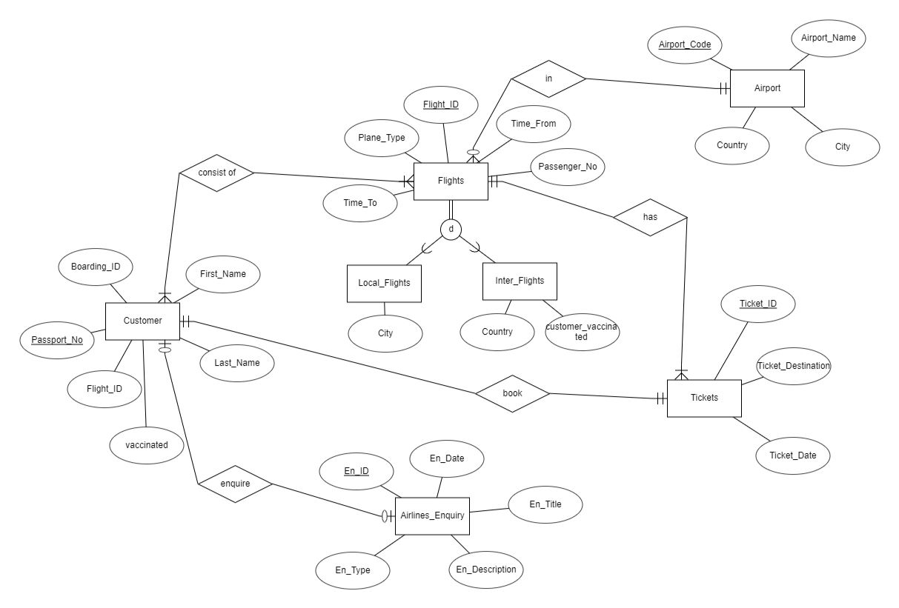

**Relational database schema:**

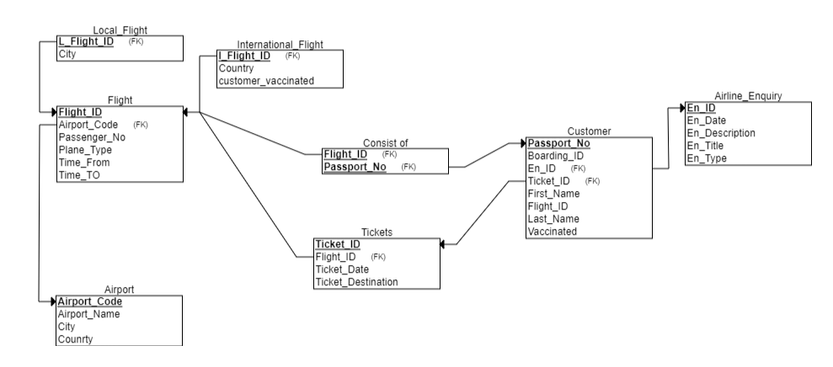

**Samples of SQL:**

**Used Tools:**

My SQL

Eclipse

**SQL Code:**

CREATE TABLE `tickets` (

`Ticket_id` int NOT NULL AUTO_INCREMENT,

**`**FLIGHT_ID` int NOT NULL,

`Ticket_Date` date DEFAULT NULL,

`Ticket_Destination` varchar(30) DEFAULT NULL,

PRIMARY KEY (`Ticket_id`),

KEY `FLIGHT_ID` (`FLIGHT_ID`) /*!80000 INVISIBLE */,

KEY `tickets_ibfk_2_idx` (`Ticket_id`),

CONSTRAINT `fk` FOREIGN KEY (`FLIGHT_ID`) REFERENCES `flights` (`FLIGHT_ID`) ON DELETE CASCADE ON UPDATE CASCADE

) ENGINE=InnoDB AUTO_INCREMENT=316 DEFAULT CHARSET=utf8mb4 COLLATE=utf8mb4_0900_ai_ci;

/*!40101 SET character_set_client = @saved_cs_client */;

**GUI Screen shots:**

